Description of application

Observer pattern

Dimitar Markov – ei4s1

The topic of the application is lottery. From the main window you have controls for drawing numbers, you can also schedule automatic draw. There you would also find the buttons for starting participants.

The application consists of one project, which is divided in 6 classes for the purpose of demonstrating the observer pattern.

1. ILottery - Subject
2. Lottery - Concreate subject
3. IParticipant - Observer
4. Participant1 – Concrete observer
5. Participant2 – Concreate observer
6. Form1 – Starting point of the application

Class diagram (I made it digital because it got quite ugly and time consuming):

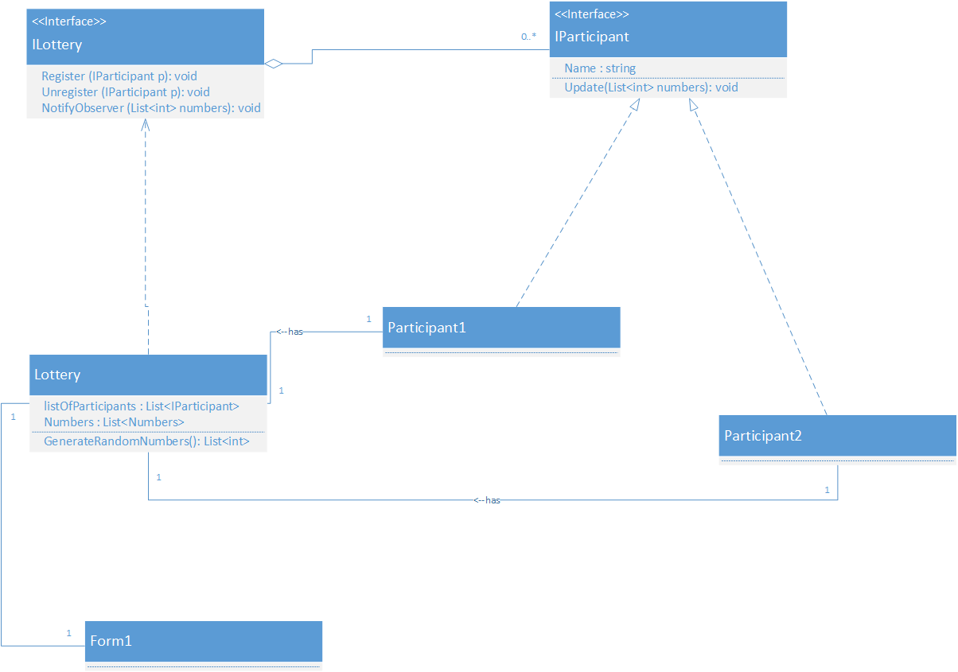

Implementation:

It is minimalistic with one purpose to display the use of observer pattern

Please refer to the project and the comment inside for further details.